Q10. Carefully read the explanation of the following assembly language program and then answer the sub-question.

[Description of Program]
This sub-program group deletes and creates a unidirectional list. A list starts at ROOT, and each element consists of a value and a pointer to the following element. “NULL” is stored in the element pointer at the end of the list. Fig. 1 shows an example of a unidirectional list.

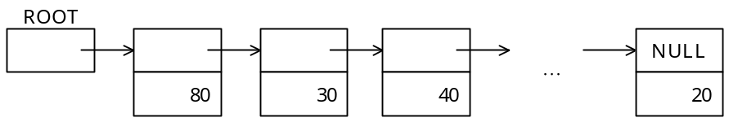
Fig. 1 Unidirectional List

(1) The list area is an area of “FLSIZE” words that begins at “FLIST” (even address) and which is used to store elements. Each element consists of two words, and has the structure shown in Fig. 2. “F” is a one-bit flag that indicates whether an element is in use or not; this flag is used by the garbage collection (“GC”) subprogram. “Address” and “F” together comprise one word, and are used as a pointer to the next element. “NULL” is indicated by “#0000.” “V” stores the value of the element.

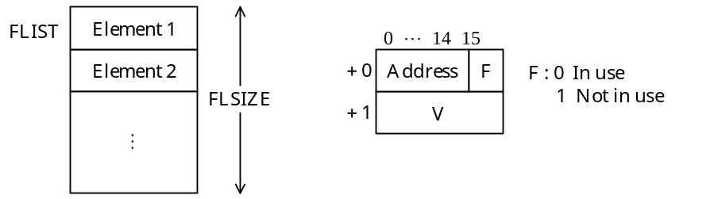
Fig. 2 Structures of List Area and Elements

(2) Initially, the main program calls the subprogram FLINIT to perform initialization process.
(3) Initialization process that is performed by the subprogram “FLINIT” is as follow (the program is omitted).
• Stores “NULL” in “ROOT.”
• Stores the next address after the last address of the list area (“FLIST” + “FLSIZE”) in “FLMAXP.” “FLMAXP” is used by the subprogram “GC.”
• Creates a unidirectional list (called a “free list”) that links all of the elements in the list area, and then stores the first address of the list into “FLPTR.”
(4) The subprogram “GC” collects all of the elements in the list area that are not being used (for which “F” is set to “Not in use”) and creates a free list, and then stores the first address of the list in “FLPTR.” (The program is omitted).
(5) The subprogram “GET” gets one element from a free list. Each time that “GET” is called, the first address of the element that was gotten is stored in “GR1.” However, if there are no more elements in the free list, the subprogram “GC” is called and the free list is created again. If there are still no elements in the list, the program outputs a message and terminates.
(6) The sub-program “ADD” creates an element with the value that is stored in “GR0,” and inserts the element at the start of the list that begins at “ROOT.” The main program stores the additional data in “GR0” and calls “ADD.” Fig. 3 shows an example of how an element containing the value “25” is added to the list shown in Fig. 1.

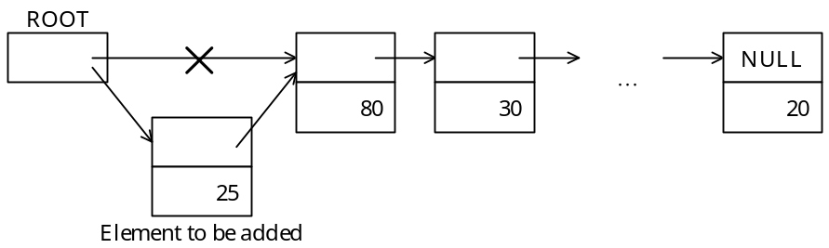
Fig. 3 Inserting an Element in a List

(7) The sub-program “DEL” searches sequentially for elements in the list starting from “ROOT,” and if it finds an element that has the same value as “GR0,” it deletes that element. The main program stores the data to be deleted in “GR0,” and then calls “DEL.” Fig. 4 shows an example in which an element with the value “30” is deleted from the list in Fig. 1.

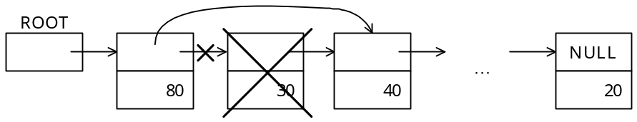
Fig. 4 Deleting an Element from a List

(8) When control returns from “ADD” or “DEL,” the contents of the GR1 through GR3 general-purpose registers are restored to their original states.
(9) When control returns from “GET,” the contents of the GR2 and GR3 general-purpose registers are restored to their original states.
[Program]

; Adds an element to the list
; Parameter GR0: Value to be added
ADD PUSH 0,GR1
ST GR0,TEMP
CALL GET ; Gets an element from the list
LD GR0,TEMP

LD GR0,ROOT
 ; Adds to the list
ST GR1,ROOT
POP GR1
RET

; Deletes an element from the list
; Parameter GR0: Value to be deleted
DEL PUSH 0,GR1
PUSH 0,GR2
PUSH 0,GR3
LEA GR1,ROOT
LD GR2,0,GR1
DLOOP LEA GR2,0,GR2
JZE DEND ; End of list
CPA GR0,1,GR2 ; Was identical value found?
JZE DELEND
LEA GR1,0,GR2

JMP DLOOP
DELEND 
ST GR3,0,GR1
LD GR3,FLAG
ST GR3,0,GR2
DEND POP GR3
POP GR2
POP GR1
RET

; Gets an element from the free list
; Parameter: None
; Result GR1: Address of element
GET LD GR1,FLPTR
LEA GR1,0,GR1
JNZ GL01
CALL GC ; Calls sub-program GC
LD GR1,FLPTR
LEA GR1,0,GR1

OUT ERMSG,ERMLEN ; No empty elements
EXIT
GL01 LD GR0,0,GR1
ST GR0,FLPTR
RET
FLIST DS 1000
FLSIZE DC 1000
FLMAXP DS 1
FLPTR DS 1
FLAG DC 1
ERMSG DC 'NO AVAILABLE ELEMENT'
ERMLEN DC 20
ROOT DS 1
TEMP DS 1
END

Sub-Question
Select the correct answers to be inserted into the corresponding boxes () in the above program from the choices provided below.

Answer group for a and b:
a) ST GR0,0,GR1 b) ST GR0,1,GR1 c) ST GR2,0,GR1
d) ST GR2,1,GR1 e) ST GR3,0,GR1 f) ST GR3,1,GR1

Answer group for c and d:
a) LD GR0,0,GR2 b) LD GR0,1,GR2 c) LD GR2,0,GR2
d) LD GR2,1,GR2 e) LD GR3,0,GR2 f) LD GR3,1,GR2

Answer group for e:
a) JMI GL01 b) JNZ GL01 c) JPZ GL01
d) JZE GL01

